Arista Company Interview Questions  
  
**Question 1:**  
  
<https://leetcode.com/problems/maximum-depth-of-binary-tree/>

**Question 2:**

### **Problem Description:**

You are given a single integer n, where n represents the root of a binary tree. Your task is to construct a binary tree following these rules:

1. Start with n as the root.
2. Each node xxx in the tree generates two child nodes:
   * x−1x-1x−1 (left child)
   * x−2x-2x−2 (right child)
3. The tree stops expanding when a node value is less than 111 (i.e., no children are generated for such nodes).

Once the tree is constructed, count how many times each number from 111 to nnn appears in the tree.

#### **Input:**

A single integer nnn (1≤n≤621 \leq n \leq 621≤n≤62).

#### **Output:**

For each number iii from 111 to nnn, output the frequency of iii in the tree, in the following format:

css

Copy code

* i - frequency

#### **Example:**

##### **Input:**

Copy code

* 4

##### **Output:**

Copy code

* 1 - 3
* 2 - 2
* 3 - 1
* 4 - 1

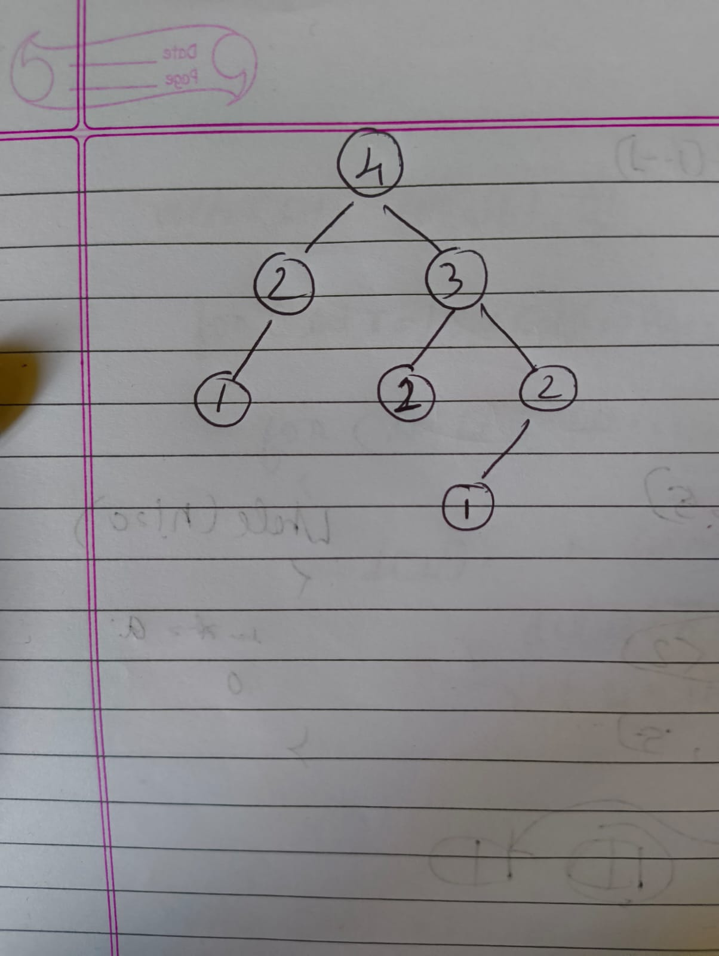

Output is 3 2 1 1

**Question 3:**

<https://github.com/doocs/leetcode/blob/main/solution/0700-0799/0788.Rotated%20Digits/README_EN.md>